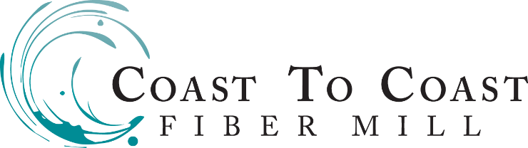
FIBER PROCESSING FORM
Print and send a form for each bag of fleece or product requested with your fiber for processing.

Mail Fiber Processing Form and Fleeces to: Coast to Coast Fiber Mill 8501 Harding Ave NE Monticello MN 55362
Deposit: A processing deposit of 50% is required at the time of receipt and will be based upon incoming weight.
Invoice: At completion of processing we will email your invoice with the final balance including any shipping costs.
Payment Methods accepted are: Check, Cash, or PayPal. A $30.00 fee will be charged for returned checks.
Pickup/Shipping: Orders available for pickup/shipping upon receipt of final payment.
All orders will be shipped USPS Priority Mail at the fleece owners expense.

Contact Information:
Name:  Address: | Phone Number:  Email Address:

Order Identifier (Animal Name, Color, etc):

Fiber Type: ☐ Suri ☐ Huacaya ☐ Wool ☐Other___________________

Order Delivery Method: ☐ Shipped (USPS Priority Mail) ☐ Pickup

Processing Requested | Additional Services Requested
☐ Skirting $25/hr | ☐ Blending Prior to Wash (+$2.00/lb)
☐ Wash Only $6.00/lb | ☐ Extra Wash (+$3.00/lb)
☐ Cloud Only (Wash/Pick Only) $8.50/lb | ☐ Blending at Picking (+$2.00/lb)
☐ Roving (Wash/Pick/Card Only) $16.00/lb | ☐ Blending at Carding (+$2.00/lb)
☐ Batt (Wash/Pick/Card Only) $16.00/lb
☐ Other (Please Specify)
☐ Rug Yarn (Cotton Core) $18.00/lb
☐ Dryer Balls $12.00/lb

Please do not send fiber under 3″ for processing (unless making cored rug yarn) or any fiber over 7″ long.

Additional Comments:
Note: All pricing is based on incoming weights so please skirt your fiber to reduce your processing costs.
Any order remaining in the mill past 60 days of completion become property of Coast to Coast Fiber Mill, LLC.
If you would like your mill waste returned you must notify us at the time your fiber is received for processing.

